Pranay Yara **Mainframe DXC,** Australia 19/07/2024

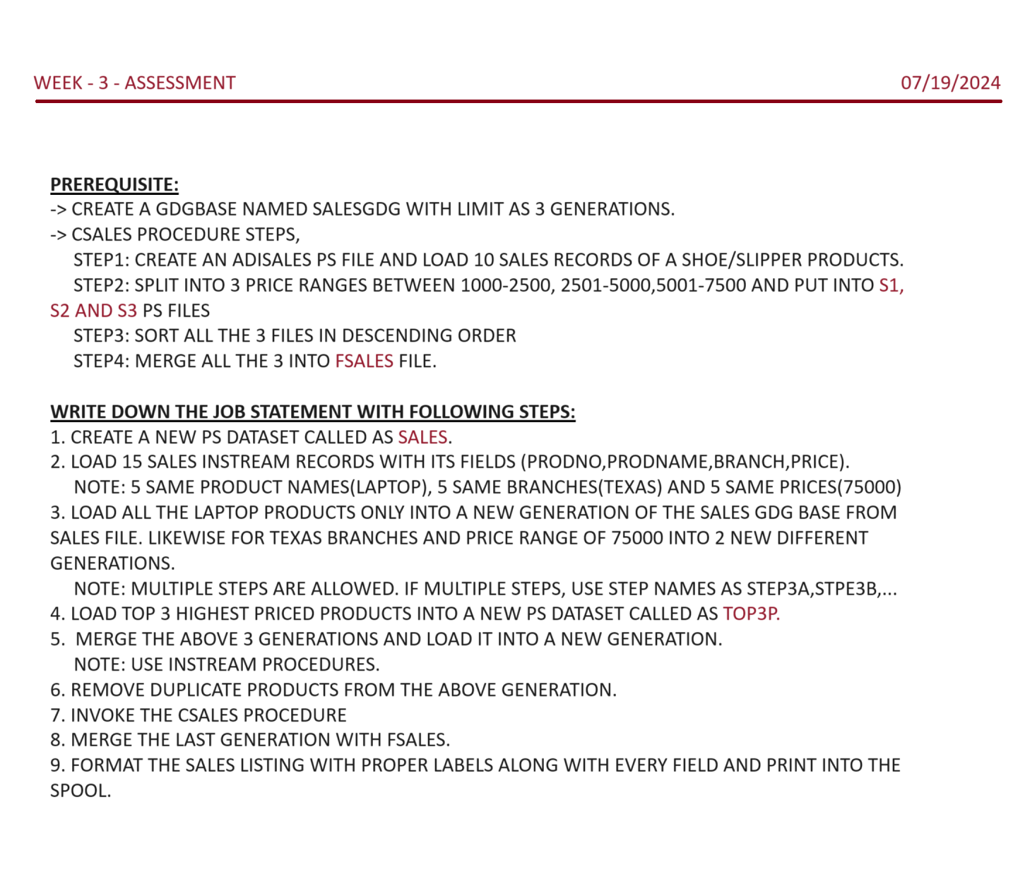

**PREREQUISITE:**

-> CREATE A GDGBASE NAMED SALESGDG WITH LIMIT AS 3 GENERATIONS.

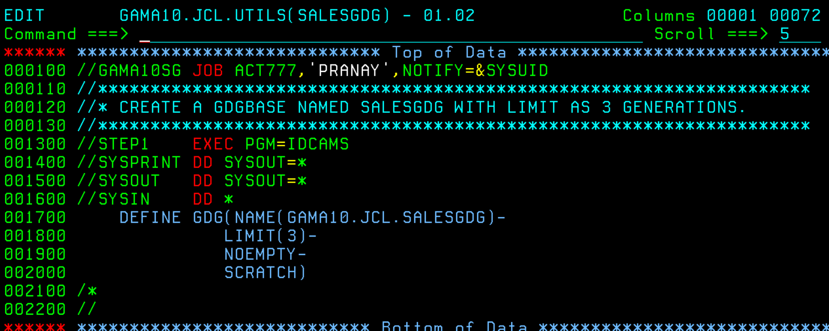

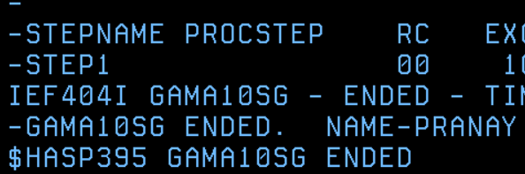



-> CSALES PROCEDURE: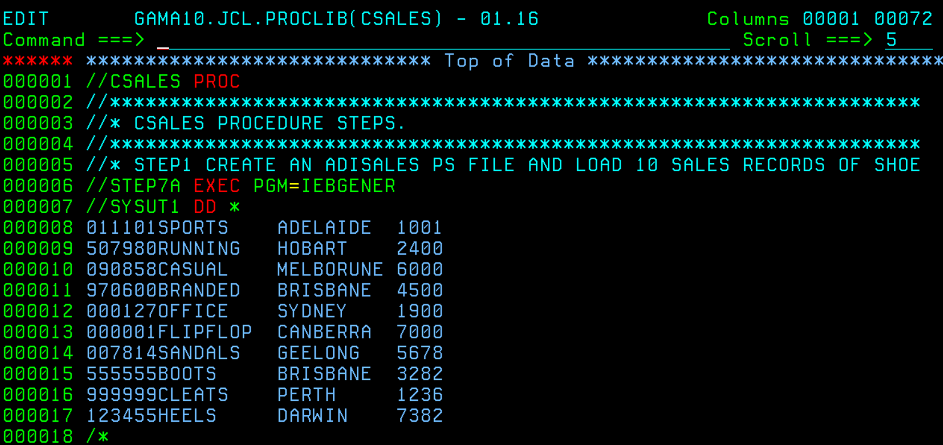

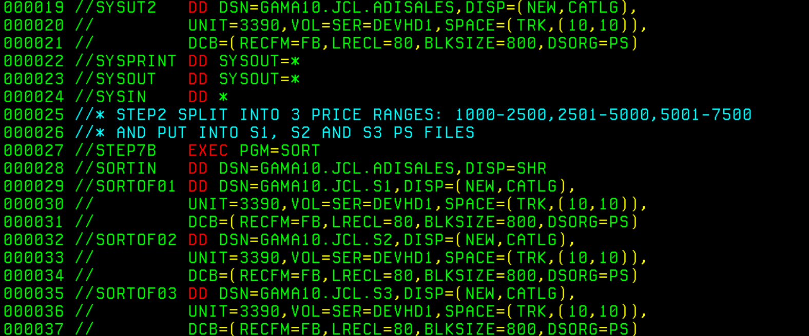

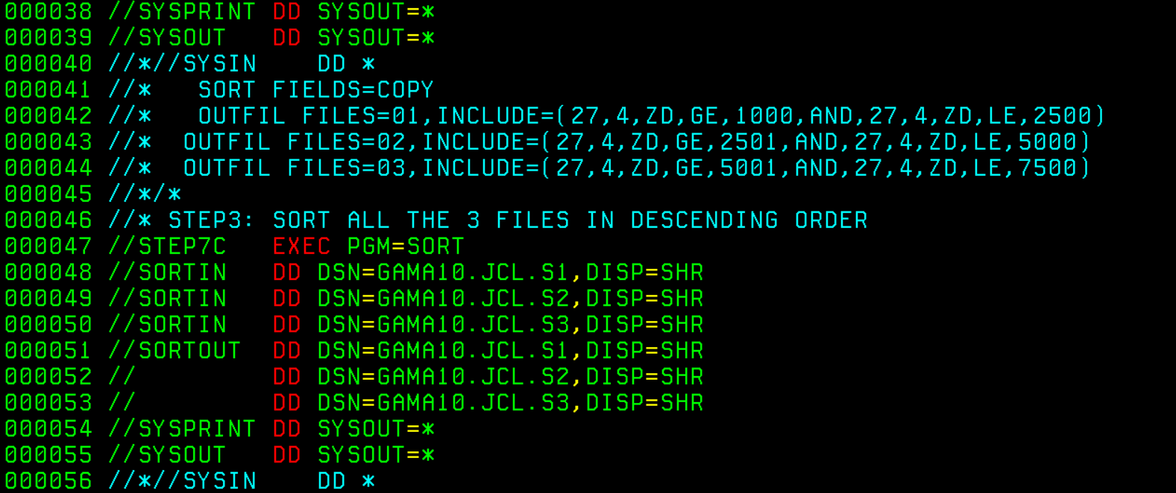

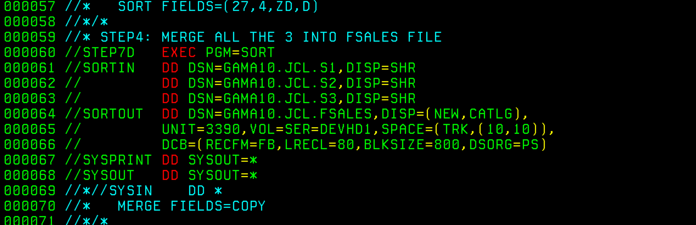

**WRITE DOWN THE JOB STATEMENT WITH FOLLOWING STEPS:**

1. CREATE A NEW PS DATASET CALLED AS SALES.

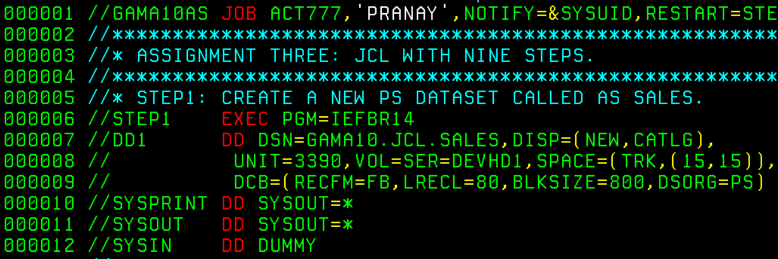

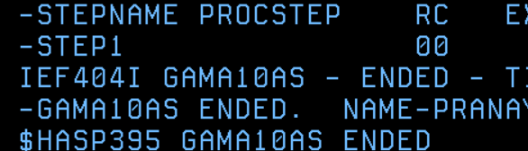



2. LOAD 15 SALES INSTREAM RECORDS WITH ITS FIELDS (PRODNO, PRODNAME, BRANCH, PRICE).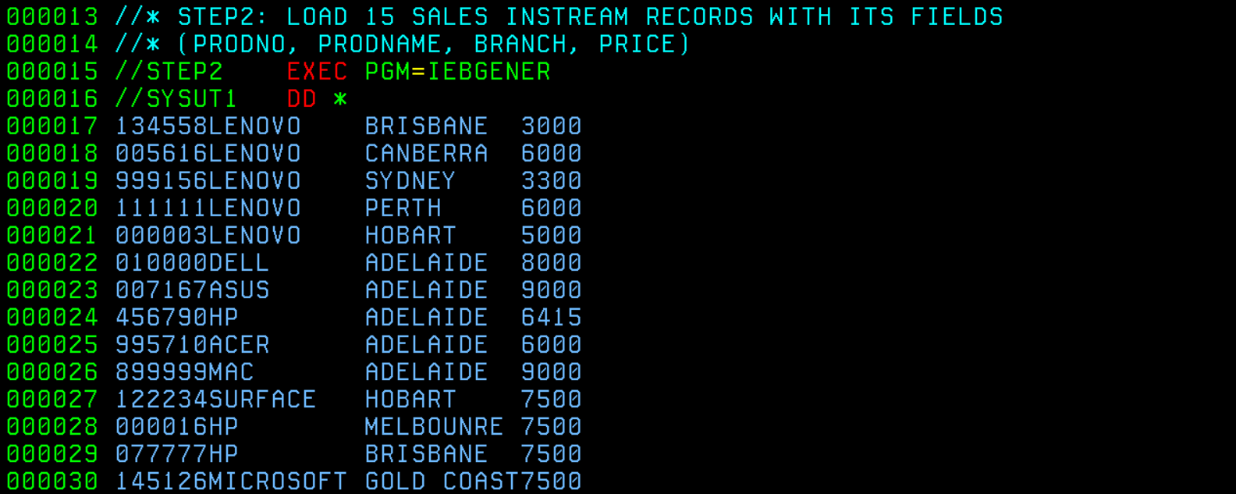

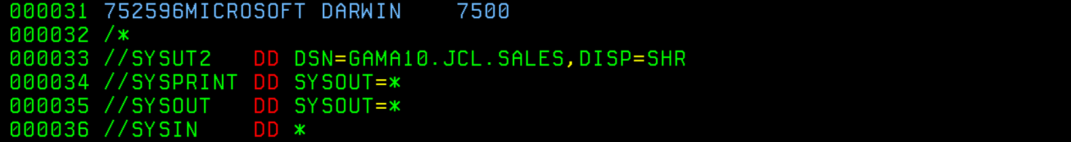

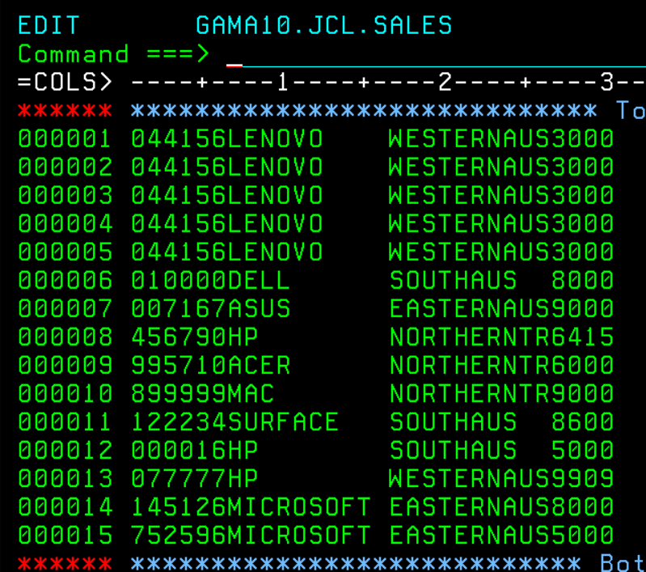

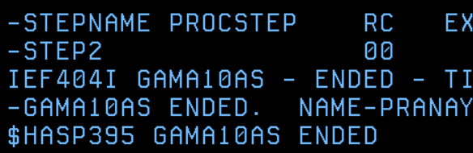

3. LOAD ALL THE LAPTOP PRODUCTS ONLY INTO A NEW GENERATION OF THE SALES GDG BASE FROM SALES FILE. LIKEWISE FOR TEXAS BRANCHES AND PRICE RANGE OF 75000 INTO 2 NEW DIFFERENT GENERATIONS.

NOTE: MULTIPLE STEPS ARE ALLOWED. IF MULTIPLE STEPS, USE STEP NAMES AS STEP3A,STPE3B,... 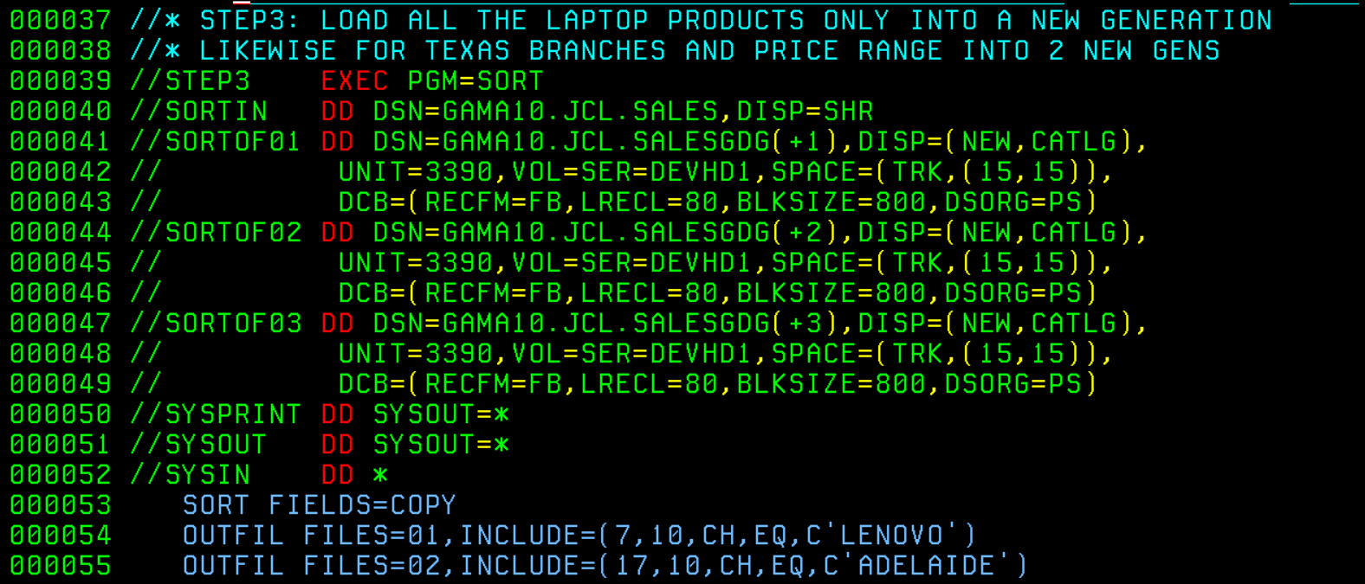



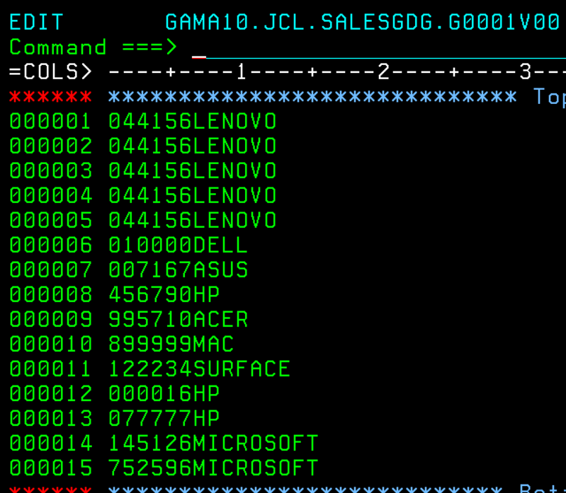

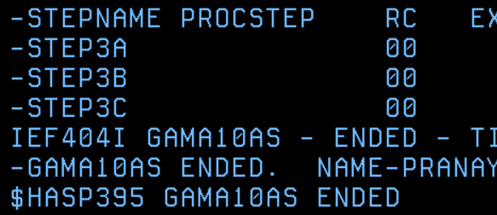

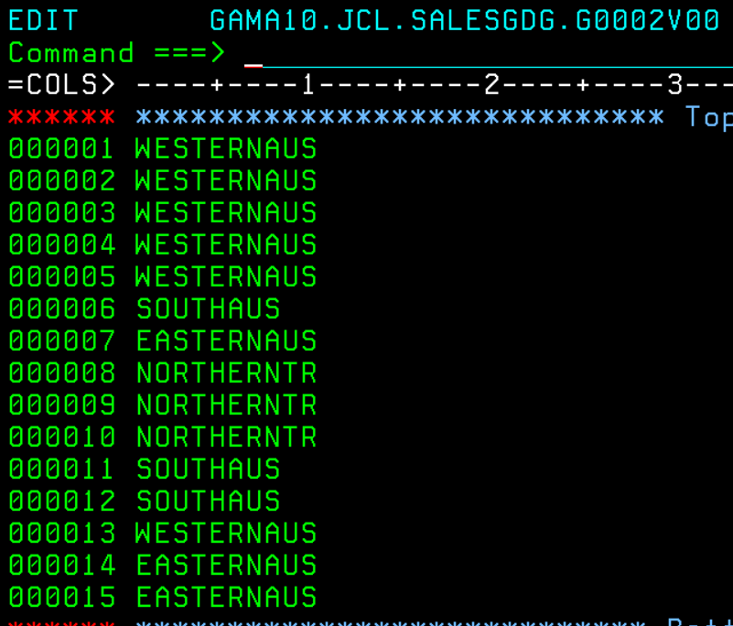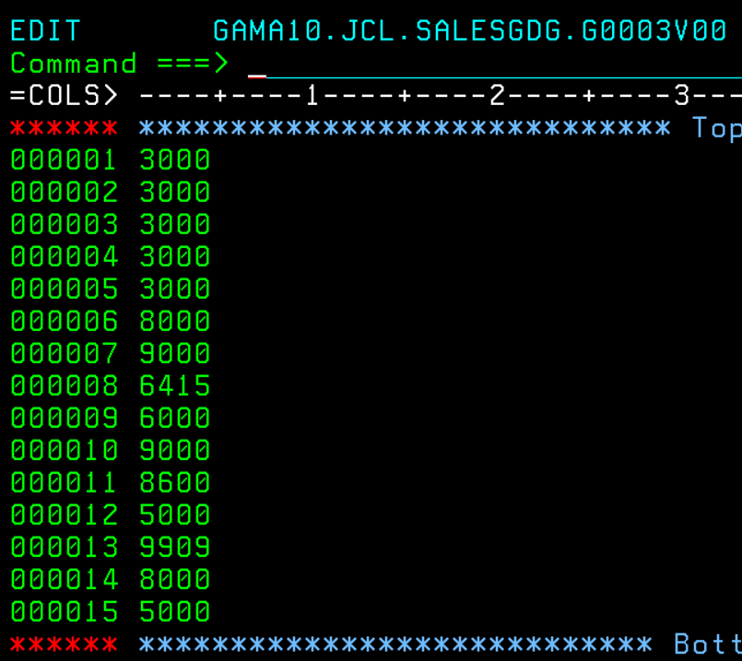

4. LOAD TOP 3 HIGHEST PRICED PRODUCTS INTO A NEW PS DATASET CALLED AS TOP3P.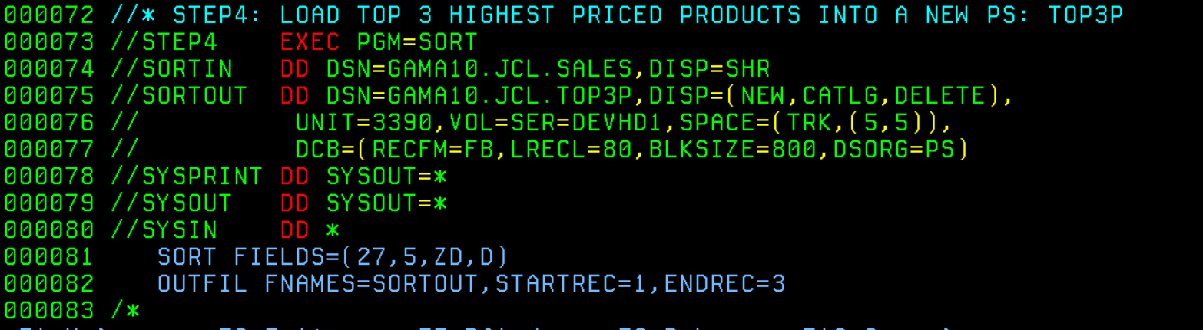

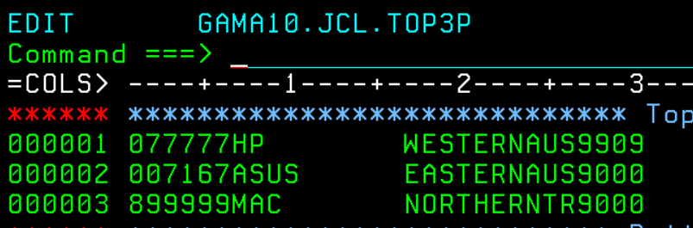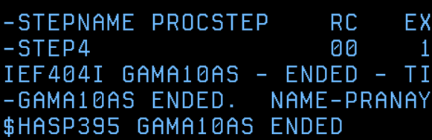

5. MERGE THE ABOVE 3 GENERATIONS AND LOAD IT INTO A NEW GENERATION.

NOTE: USE INSTREAM PROCEDURES.

As I was testing and trying to understand the +numbers and -numbers in gdgs, the file numbers in DD statements can be +1,+2,+3, and +4 (based on the previous steps) if you are running the entire job at once or -2,-1,0, and +1 if you are testing just from this step with restart parameters. Also for merging, you don’t need to use the MERGE FIELD=COPY, I used SORT FIELD=(27,4,ZD,D) because records are already merged and merged files should be sorted.

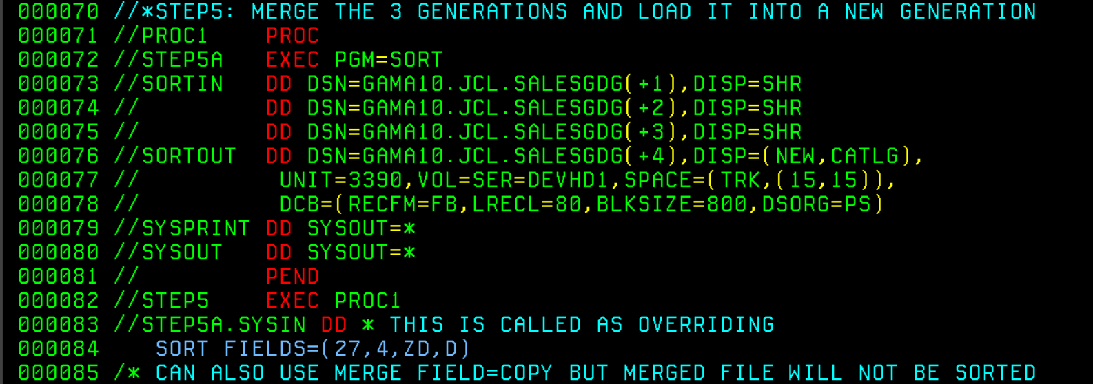

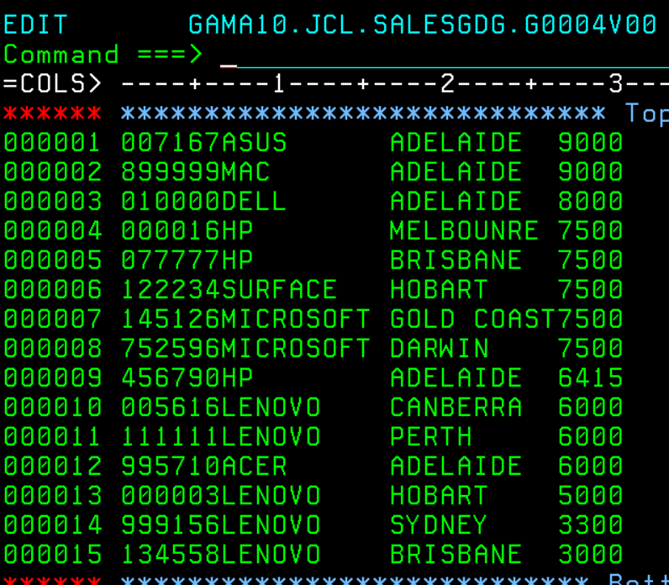

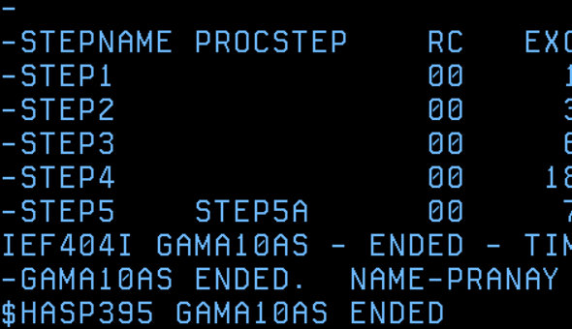

6. REMOVE DUPLICATE PRODUCTS FROM THE ABOVE GENERATION.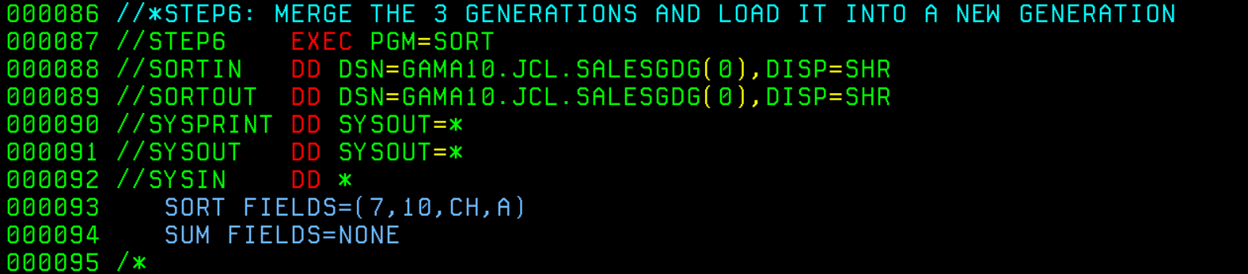

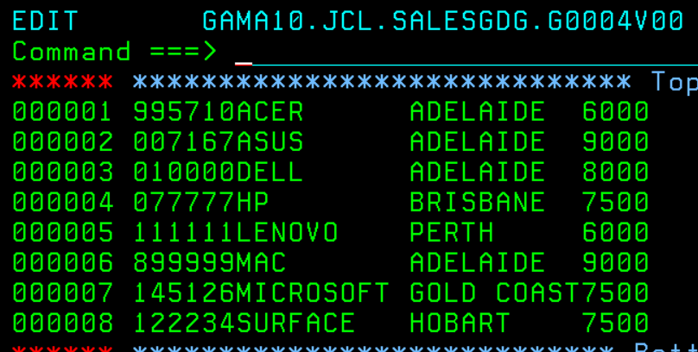

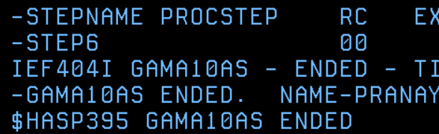

7. INVOKE THE CSALES PROCEDURE

First, when using catalog procedures, mention JCLLIB under the job card at the start of the job, as it should appear before any exec statements. Also, for some reason, RESTART=STEP7 kept giving me JCL errors, so I used RESTART=STEP6, which ended up working. Another takeaway from this step was that MERGE FIELDS = (..) and SORTINXX were giving me a lot of trouble, as I kept getting MAXCC 16 errors. I counteracted this by using MERGE=COPY, SYSIN, and SORT FIELDS. In the end, I did achieve the desired output, but I am not completely sure if these commands were the proper ones to use.

One challenge in this step was my lack of mastery over the syntax, causing me to spend a lot of time. For example, in STEP7B I got MAXCC 00 but my S1 file had all the records instead of just the ones with prices >1000 and <2500, while S2 and S3 had their correct respective outputs. I spent so much time debugging that step, trying different utility control statements. I swapped S2 and S1, which allowed S1 to have the correct output, but then S2 had all the records. I then opened a new PS file and started the entire procedure again. This time, I tested one step at a time and found that STEP7B was working fine. The issue was with STEP7C, which is meant to override sorted copies but instead overrode all the records into the first file. As I looked at the syntax, I realised I had only one SYSIN instead of a SYSIN for each of the input files. After correcting this, the file outputted properly. Additionally, when I run the procedure steps one by one, I get the correct output, but when I run them all at once, the final output in FSALES isn’t correctly sorted. I managed to fix this in STEP8.



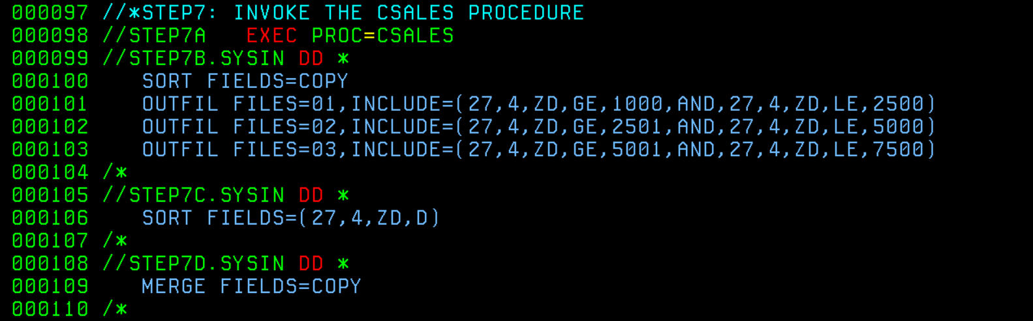

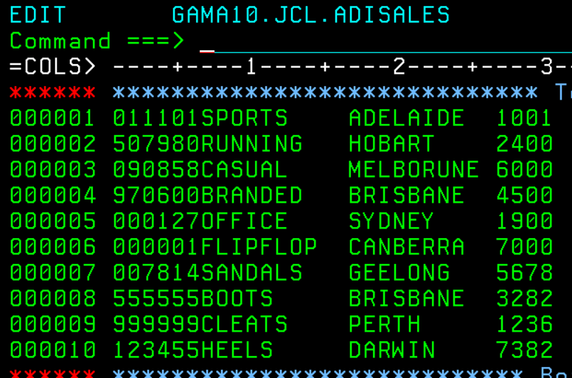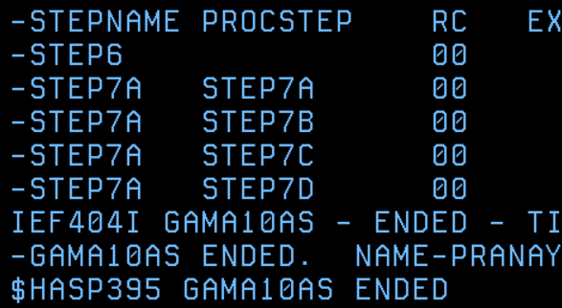

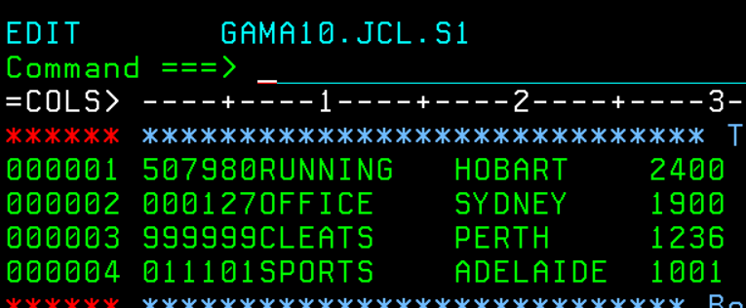

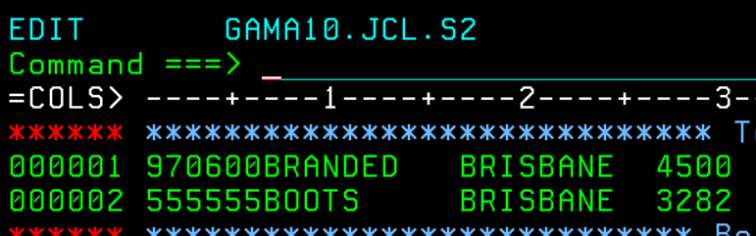

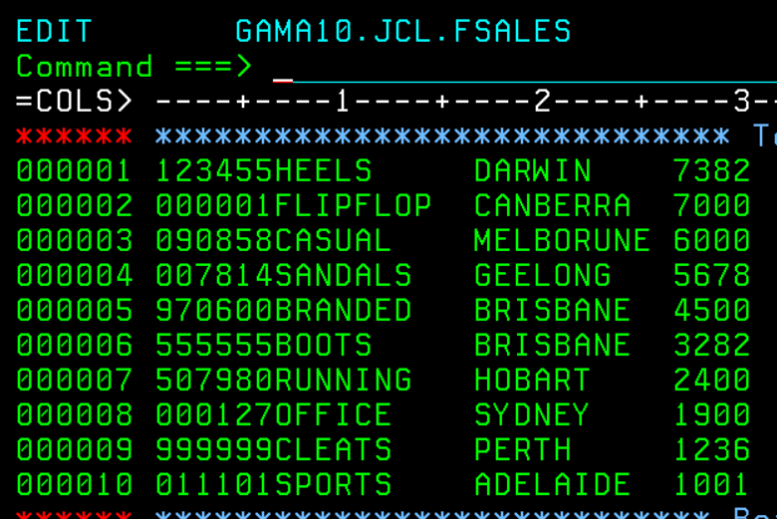

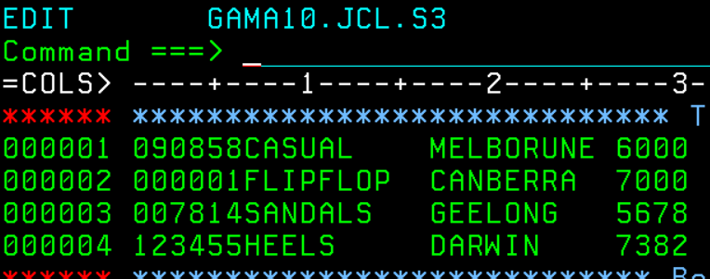

8. MERGE THE LAST GENERATION WITH FSALES.

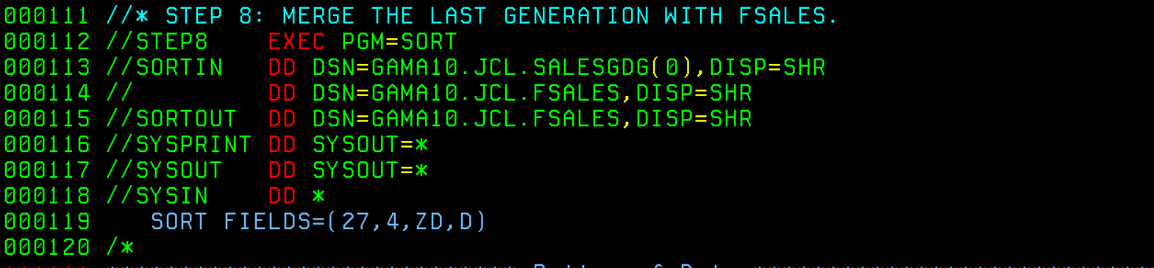

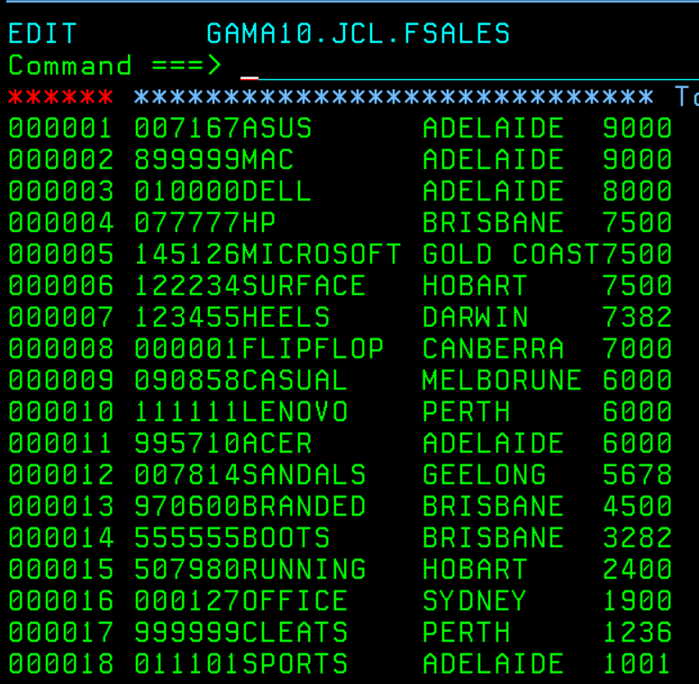

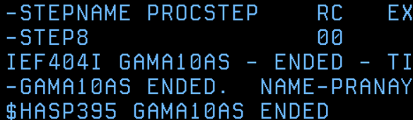

9. FORMAT THE SALES LISTING WITH PROPER LABELS ALONG WITH EVERY FIELD AND PRINT INTO THE SPOOL.

